Year 12 Biology
Marine Forensics Investigation Validation Test

Name:
Teacher:

Marks Received | Marks Available | Percentage
 | 30

Weighting 5%

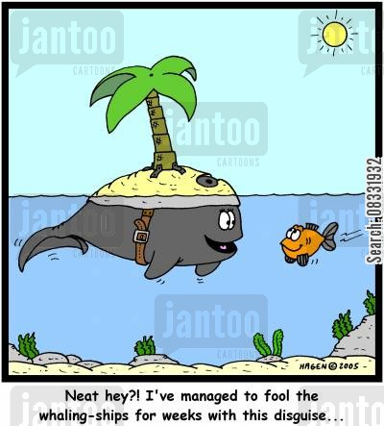

Biotechnologists use a variety of laboratory techniques which enable the comparison of DNA from different individual organisms.

In class you carried out the process of gel electrophoresis. Answer the following questions regarding that practical.

1. Micropipettes were used in the practical. What was the volume of the sample you used?
10 µL (1 mark)
2. How was contamination prevented in the sampling procedure? (2 marks)

New pipette tip was used for each sample
Tips were not touched

3. Why does the sample move through the gel? (2 marks)

DNA is negatively charged

DNA is pulled towards the positive terminal when electricity is passed through the gel

4. What two factors control the speed of its movement? (2 marks)

Size of the DNA fragment – smaller fragments move quicker through the gel

Strength of the electrical field – movement is more rapid in a stronger field
5. Why do the segments of the sample separate? (2 marks)

Each sample is made of many smaller fragments of DNA.

Smaller fragments pass through the pores in the gel more easily than the larger ones causing the sample to separate

6. How would you identify two identical segments in different samples? (1 mark)

They would have travelled the same distance in gel / theyline up next to each other on the gel

7. What is the purpose of the buffer solution? (1 mark)

Allows the electrical current from electrodes at either end of the gel to flow through the gel.

8. What would be the disadvantages of running the gel for too long or to short a time?
(2 marks)

Too short – DNA fragments may not separate enough to visible see difference in the samples

Too long – DNA fragments may reach the end of the gel and hence samples cannot be compared accurately

9. What two other biotechnological processes would have to be carried out before you could use the DNA for gel electrophoresis? Explain why each one is necessary. (4 marks)

PCR (1) to replicate the DNA so there is enough to analyse
A restriction enzyme (1) would be used to cut the DNA into fragments

10. Apart from sampling procedures, why can we not use real DNA in the classroom procedure? (2 marks)

Danger from chemicals or UV light used in staining and reading gel.

11. Explain three sources of error which could occur during this procedure. (3 marks)

- Gel placed in incorrectly (electrodes back to front) – charge runs in the wrong direction
- Gel electrophoresis may have been run for the incorrect amount of time
- Incorrect use of micro pipettes – different volumes of sample inserted into each well
- Sample not inserted into well correctly – may squirt DNA above gel in the buffer solution or too far below the gel
- Samples placed in the wrong well – incorrect interpretation of results
- Contamination – didn’t change tip
- Not enough / too much buffer solution

12. Your procedure involved a scenario regarding illegal fishing. Write a summary of your findings to the International Whaling Commission, including an explanation of how you arrived at these conclusions.

(4 marks)
The fisherman was carrying tuna
Other samples from the boat were Minke Whale and an unknown DNA sample
This was found by comparing known DNA samples
Which corresponded with the boat samples on the electrophoresis gel

13. Using second hand data:
For three years a team of researchers have been watching three different Humpback whale pods off the coast of Exmouth in Western Australia. They are especially interested in the genetic diversity of these whales. As the numbers of humpback whales are decreasing, determining the genetic diversity of these populations is increasingly more important. In particular, this team is interested in which calves belong to a particular mating pair of whales. Using second hand data you are going to help them figure this out!

Problem: Which of the three calves does not belong to the mating pair of whales shown? Explain your answer.

 | Individuals tested | DNA sample
 | Father | 1
 | Mother | 2
 | Calf A | 3
 | Calf B | 4
 | Calf C | 5

Analyzing the DNA data: Sample result

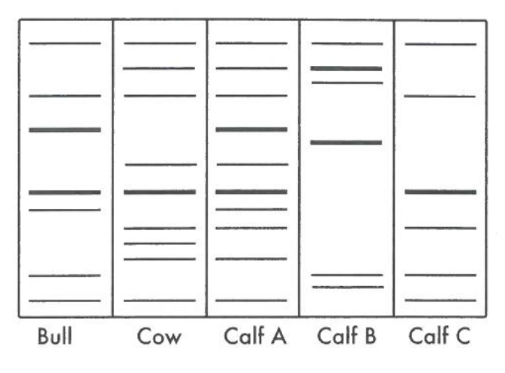

Are any of the calves offspring of the two parents? Explain fully with reference to the sample result. (4 marks)

Calf A (1) and calf C (1) are both offspring of the two parents

Banding pattern of calf A and C matches that of the parents (0.5) – all bands present in each calf are also present either the cow or the bull (0.5)

(1 mark)
Calf B is not an offspring of the parents because it has bands present in its DNA fingerprint / profile that were not in either the mother’s or father’s profile.

